4. Select any open transportation dataset containing traffic, public transport,vehicle, road accident, or passenger information. Analyze the data by location and
time, identify patterns and outliers, create charts/maps, and develop an interactive
presentation of the findings.
CODE:
import pandas as pd
import numpy as np
import matplotlib.pyplot as plt
import seaborn as sns
import plotly.express as px
sns.set_theme(style="whitegrid")
df=pd.read_csv("US_Accidents.csv")
print(df.shape)
print(df.head())
df["Start_Time"]=pd.to_datetime(df["Start_Time"],errors="coerce")
df["Hour"]=df["Start_Time"].dt.hour
df["Day"]=df["Start_Time"].dt.day_name()
df["Month"]=df["Start_Time"].dt.month
df["Year"]=df["Start_Time"].dt.year
df=df.dropna(subset=["Start_Time","Start_Lat","Start_Lng"])
print("Total Records:",len(df))
print("Missing Values:\n",df.isnull().sum().head(20))
state_accidents=df["State"].value_counts().head(15)
state_accidents.plot(kind="bar",figsize=(12,6))
plt.title("Top 15 States by Number of Accidents")
plt.xlabel("State")
plt.ylabel("Number of Accidents")
plt.xticks(rotation=45)
plt.tight_layout()
plt.show()
city_accidents=df["City"].value_counts().head(15)
city_accidents.plot(kind="bar",figsize=(12,6))
plt.title("Top 15 Cities by Number of Accidents")
plt.xlabel("City")
plt.ylabel("Number of Accidents")
plt.xticks(rotation=60)
plt.tight_layout()
plt.show()
hour_accidents=df["Hour"].value_counts().sort_index()
plt.figure(figsize=(12,6))
plt.plot(hour_accidents.index,hour_accidents.values,marker="o")
plt.title("Traffic Accidents by Hour of Day")
plt.xlabel("Hour")
plt.ylabel("Number of Accidents")
plt.xticks(range(24))
plt.grid(True)
plt.tight_layout()
plt.show()
day_order=["Monday","Tuesday","Wednesday","Thursday","Friday","Saturday","Sunday"]
day_accidents=df["Day"].value_counts().reindex(day_order)
day_accidents.plot(kind="bar",figsize=(10,5))
plt.title("Accidents by Day of Week")
plt.xlabel("Day")
plt.ylabel("Number of Accidents")
plt.xticks(rotation=45)
plt.tight_layout()
plt.show()
monthly_accidents=df.groupby("Month").size()
plt.figure(figsize=(10,5))
plt.plot(monthly_accidents.index,monthly_accidents.values,marker="o")
plt.title("Monthly Traffic Accident Trend")
plt.xlabel("Month")
plt.ylabel("Number of Accidents")
plt.xticks(range(1,13))
plt.grid(True)
plt.tight_layout()
plt.show()
yearly_accidents=df.groupby("Year").size()
plt.figure(figsize=(10,5))
plt.plot(yearly_accidents.index,yearly_accidents.values,marker="o")
plt.title("Yearly Traffic Accident Trend")
plt.xlabel("Year")
plt.ylabel("Number of Accidents")
plt.grid(True)
plt.tight_layout()
plt.show()
severity=df["Severity"].value_counts().sort_index()
severity.plot(kind="bar",figsize=(8,5))
plt.title("Accidents by Severity")
plt.xlabel("Severity")
plt.ylabel("Number of Accidents")
plt.tight_layout()
plt.show()
weather=df["Weather_Condition"].value_counts().head(10)
weather.plot(kind="bar",figsize=(12,6))
plt.title("Top 10 Weather Conditions During Accidents")
plt.xlabel("Weather Condition")
plt.ylabel("Number of Accidents")
plt.xticks(rotation=45)
plt.tight_layout()
plt.show()
plt.figure(figsize=(10,5))
sns.histplot(df["Temperature(F)"].dropna(),bins=30,kde=True)
plt.title("Temperature Distribution During Accidents")
plt.xlabel("Temperature (°F)")
plt.ylabel("Frequency")
plt.tight_layout()
plt.show()
temperature=df["Temperature(F)"].dropna()
Q1=temperature.quantile(0.25)
Q3=temperature.quantile(0.75)
IQR=Q3-Q1
lower_limit=Q1-1.5*IQR
upper_limit=Q3+1.5*IQR
outliers=df[(df["Temperature(F)"]<lower_limit)|(df["Temperature(F)"]>upper_limit)]
print("Number of Temperature Outliers:",len(outliers))
print(outliers[["State","City","Temperature(F)"]].head(10))
numeric_columns=["Severity","Temperature(F)","Humidity(%)","Pressure(in)","Visibility(mi)","Wind_Speed(mph)"]
available_columns=[col for col in numeric_columns if col in df.columns]
correlation=df[available_columns].corr()
print(correlation)
plt.figure(figsize=(10,7))
sns.heatmap(correlation,annot=True,fmt=".2f",cmap="coolwarm")
plt.title("Transportation Data Correlation")
plt.tight_layout()
plt.show()
map_data=df.sample(min(5000,len(df)),random_state=42)
fig=px.scatter_map(map_data,lat="Start_Lat",lon="Start_Lng",color="Severity",hover_name="City",hover_data=["State","Weather_Condition"],zoom=3,height=600,title="Interactive Traffic Accident Map")
fig.show()
print("Total Accidents:",len(df))
print("State with Most Accidents:",df["State"].value_counts().idxmax())
print("City with Most Accidents:",df["City"].value_counts().idxmax())
print("Most Common Accident Hour:",df["Hour"].value_counts().idxmax())
print("Most Common Accident Day:",df["Day"].value_counts().idxmax())
print("Most Common Weather:",df["Weather_Condition"].value_counts().idxmax())
print("Number of Temperature Outliers:",len(outliers))
OUTPUT:
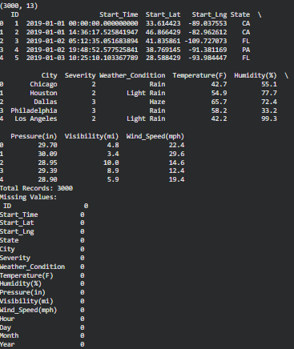

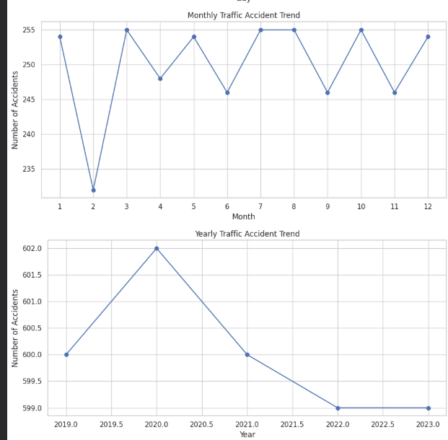
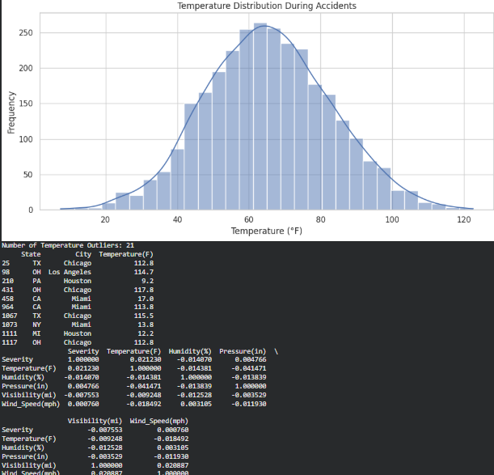
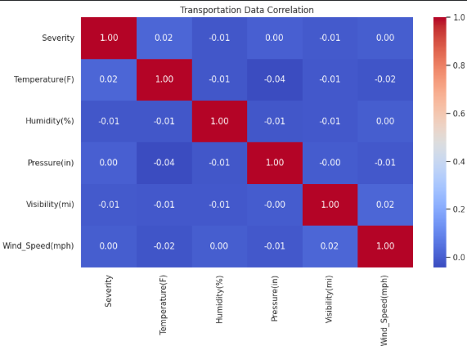
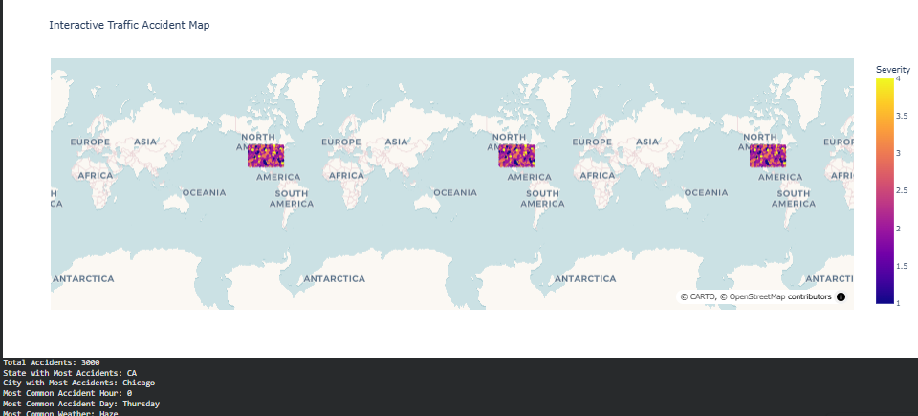

5. Select any open economic or financial dataset containing GDP, employment,
inflation, trade, income, or expenditure information. Explore the data, combine
multiple datasets where applicable, identify correlations and outliers, create
meaningful groups, analyze trends, visualize the results, and publish the completed
project using an open-source platform.

CODE:
import pandas as pd
import numpy as np
import matplotlib.pyplot as plt
import seaborn as sns
import plotly.express as px
gdp=pd.read_csv("GDP.csv")
inflation=pd.read_csv("Inflation.csv")
employment=pd.read_csv("Employment.csv")
gdp.columns=gdp.columns.str.strip()
inflation.columns=inflation.columns.str.strip()
employment.columns=employment.columns.str.strip()
print(gdp.head())
print(inflation.head())
print(employment.head())
df=pd.merge(gdp,inflation,on=["Country","Year"],how="inner")
df=pd.merge(df,employment,on=["Country","Year"],how="inner")
print("Combined Dataset:")
print(df.head())
print("Dataset Shape:",df.shape)
print("\nMissing Values:")
print(df.isnull().sum())
countries=["India","United States","China"]
selected=df[df["Country"].isin(countries)]
plt.figure(figsize=(12,6))
for country in countries:
temp=selected[selected["Country"]==country]
plt.plot(temp["Year"],temp["GDP"],marker="o",label=country)
plt.title("GDP Trend")
plt.xlabel("Year")
plt.ylabel("GDP")
plt.legend()
plt.grid(True)
plt.show()
plt.figure(figsize=(12,6))
for country in countries:
temp=selected[selected["Country"]==country]
plt.plot(temp["Year"],temp["Inflation"],marker="o",label=country)
plt.title("Inflation Trend")
plt.xlabel("Year")
plt.ylabel("Inflation (%)")
plt.legend()
plt.grid(True)
plt.show()
plt.figure(figsize=(12,6))
for country in countries:
temp=selected[selected["Country"]==country]
plt.plot(temp["Year"],temp["Employment"],marker="o",label=country)
plt.title("Employment Trend")
plt.xlabel("Year")
plt.ylabel("Employment")
plt.legend()
plt.grid(True)
plt.show()
plt.figure(figsize=(10,6))
sns.scatterplot(data=df,x="Inflation",y="GDP",hue="Country")
plt.title("GDP vs Inflation")
plt.xlabel("Inflation (%)")
plt.ylabel("GDP")
plt.show()
numeric_columns=["GDP","Inflation","Employment"]
correlation=df[numeric_columns].corr()
print("Correlation Matrix:")
print(correlation)
plt.figure(figsize=(8,6))
sns.heatmap(correlation,annot=True,fmt=".2f",cmap="coolwarm")
plt.title("Economic Indicators Correlation")
plt.show()
Q1=df["GDP"].quantile(0.25)
Q3=df["GDP"].quantile(0.75)
IQR=Q3-Q1
lower=Q1-1.5*IQR
upper=Q3+1.5*IQR
outliers=df[(df["GDP"]<lower)|(df["GDP"]>upper)]
print("GDP Outliers:")
print(outliers[["Country","Year","GDP"]].head(20))
df["GDP_Group"]=pd.cut(df["GDP"],bins=[0,1e11,1e12,1e13,np.inf],labels=["Low GDP","Medium GDP","High GDP","Very High GDP"])
print(df[["Country","Year","GDP","GDP_Group"]].head(20))
top_countries=df.groupby("Country")["GDP"].mean().sort_values(ascending=False).head(15)
plt.figure(figsize=(12,6))
top_countries.plot(kind="bar")
plt.title("Top 15 Countries by Average GDP")
plt.xlabel("Country")
plt.ylabel("Average GDP")
plt.xticks(rotation=60)
plt.show()
fig=px.line(df,x="Year",y="GDP",color="Country",title="Interactive GDP Trend")
fig.show()
latest_year=df["Year"].max()
latest_data=df[df["Year"]==latest_year]
fig=px.choropleth(latest_data,locations="Country_Code",color="GDP",hover_name="Country",title=f"Global GDP - {latest_year}",color_continuous_scale="Viridis")
fig.show()
print("\nECONOMIC ANALYSIS SUMMARY")
print("Highest average GDP country:",top_countries.index[0])
print("Highest average GDP:",top_countries.iloc[0])
print("Number of GDP outliers:",len(outliers))
print("Analysis completed successfully!")

OUTPUT:
